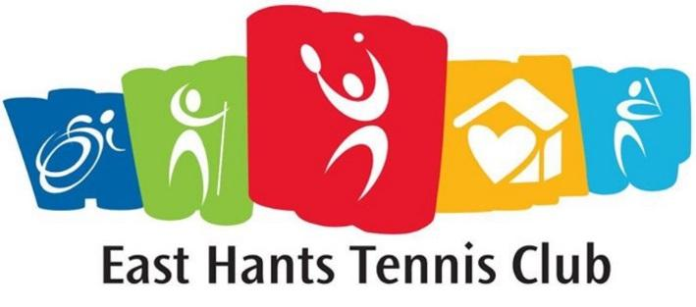
Head Tennis Instructor / Program Coordinator
Milford Tennis Courts
2288 Hwy # 2 Milford, Hants Co., NS
10 Week Term Position starting June 17 2019
30 hours per week
$15 per hour

Application Closes on March 31 2019

The head tennis instructor / program coordinator must play a high level of tennis, enjoy working with
kids, be organized, passionate about tennis and up to the age of 30 years old. This person will develop,
coordinate and coach all aspects of kid’s tennis and adult lessons, tournaments and other events.
The head tennis instructor will work with a junior coach.

Responsibilities:
- Develop, implement and coordinate innovative junior and adult programming
aligned with Tennis NS and Tennis Canada curriculum
- Conduct learn to play sessions before regular season
- Kids tennis lessons
- Adult tennis lessons
- Social tennis events
- Private / semi private lessons
- Build new club membership
- Coordinate competitive events with other clubs
- Submit weekly progress reports
- Submit daily attendance records
- Organize biweekly tournaments
- Plan end of season program event
- Program evaluation
Qualifications:
- Tennis Canada certified instructor/ coach certification (or will complete - club to cover cost)
- Standard First Aid
- Familiarity with progressive tennis
- Strong communication, organization and creative thinking skills

Attendance at Coaches Workshop by Tennis NS is mandatory. Tennis NS Technical Director will provide support
to instructor through resources and consultation.
Email application to EastHantsTennis@gmail.com
Only successful applicants will be contacted.

*Vulnerable Sector screening package must be completed prior to being hired*

