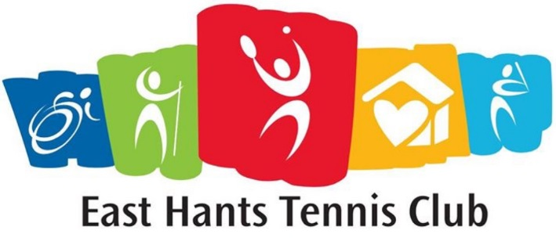
Junior Tennis Instructor / Program Delivery
Milford Tennis Courts
2288 Hwy # 2 Milford, Hants Co., NS
10 Week Term Position starting June 17 2019
30 hours per week
$12 per hour

Application Closes on March 31st 2019

The junior instructor must enjoy playing sports, being outdoors and working with kids. He/she must have good organizational skills and be attending post-secondary education in the fall. Tennis experience is required. This person will work alongside our head tennis instructor / program coordinator to deliver 10 weeks of tennis programming.

Responsibilities: To support the head instructor with these tasks:
- Help deliver the tennis lesson program
- Assist with events (social and competitive)
- Promote tennis to youth and all participants at all levels
- Help coordinate all competitive events
- Help to plan end of season program event
- Program evaluation
Qualifications:
- Tennis Canada certified instructor/ coach certification (or will complete - club to cover cost)
- Standard first aid
- Familiarity with progressive tennis
- Keen interest in sporting activities and have athletic ability
- Strong communication, organization and creative thinking skills

Attendance at coaches’ workshop by Tennis NS is mandatory. Tennis NS Technical Director will provide support to instructors through resources and consultation.
Email application to EastHantsTennis@gmail.com
Only successful applicants will be contacted.

*Vulnerable Sector screening package must be completed prior to being hired*

